**Change Request -Tour Package**

1. Add a new UI named “Tag setup for Location”

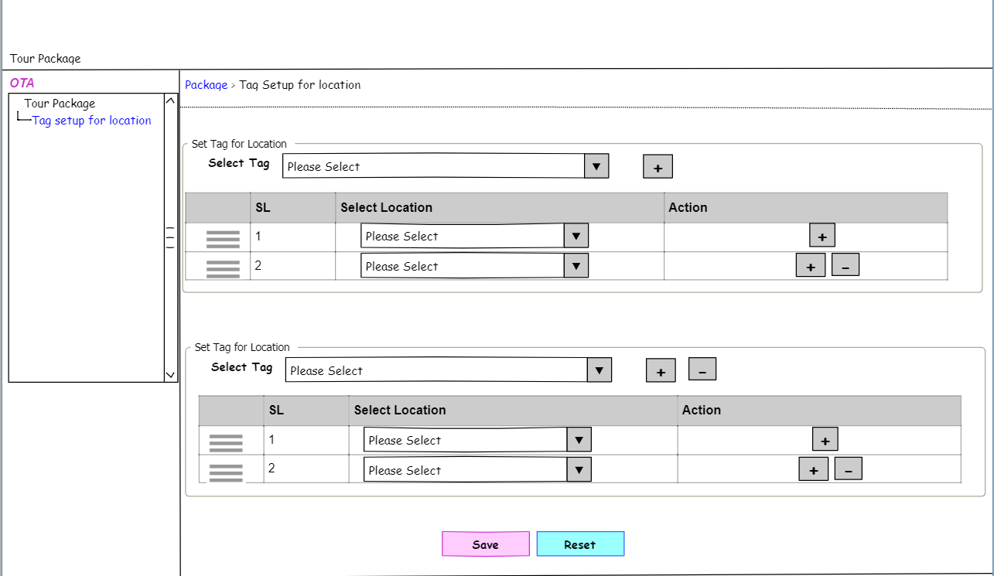

Figure – Tag setup for location

* 1. RSD – Tag setup for location

|  |  |
| --- | --- |
| **SRS ID** | SRS1.1 |
| **SRS Title** | Tag setup for location |
| **Proposed Requirement** | 1. Users will be able to save tag setup for location with required data through this UI |
| **Precondition** | 1. The user must have a valid user ID and Password to log into the system. 2. The user must have permission for this function and access this UI. |
| **Business rules** | 1. The user will be able to navigate the UI the following way: Tour Package > Admin > Tag setup for location. 2. The system will keep the user in the UI till any further action is taken by the user after saving. 3. The user will be able to drag & drop the location in the list after saving under each tag. 4. For each tag, the system will not allow the user to save more than 6 countries. 5. On clicking the “Reset” button the system will clear the entered data from the respective fields for new data entry on the coming for new data entry. On coming for modification if the user clicks the “Reset” button after any modification the system will retrieve the last saved data in the respective field in editable mode.  |  |  |  |  |  | | --- | --- | --- | --- | --- | | Sl No | Filed Name | Is Required | Data Type | Business Rules | | 1 | Select Tag | Yes | Dropdown | 1. Allows partial search 2. Users will be able to select single values. 3. Clicking add more beside this field will load the same section and allow the user to set another tag for the location 4. The user will be add more or remove tag setup 5. To save information at least a selection of one tag and one location is required. | | 2 | SL No | Yes | Read-only | 1. System generated incremental serial no. 2. Example: 1,2,3 | | 3 | Select location | Yes | Dropdown | 1. Allows partial search 2. Users will be able to select single values. 3. Clicking add more beside this field will load the same section and allow the user to set another tag for the location 4. The user will be able to add more or remove locations. 5. To save information at least a selection of one location is required. | |
| **Post-Condition** | 1. Based on the setup the system will show the tag in read-only mode in location setup. 2. Based on the setup the system will show the location under the respective tag in B2C public site. |
| **Requirement Collection Method** | Document Analysis, Existing system Analysis, Requirements gathering session. |
| **Priority** | High |

1. Showing notification for inquiry response
   1. On clicking the notification icon the system will show a toast message box where the system will show “Today you have 42 Inquiries remainder to communication. Please check”
2. Showing of request in “My booking”
   1. Show inquiry request in my booking under “current booking” and the status will show on the web named “Requested”
   2. Declined or closed inquiry requests will not show in my booking.
   3. My booking system will show "confirmed" if the payment is partial.
3. Change in the tour package creation “ Package Price” part

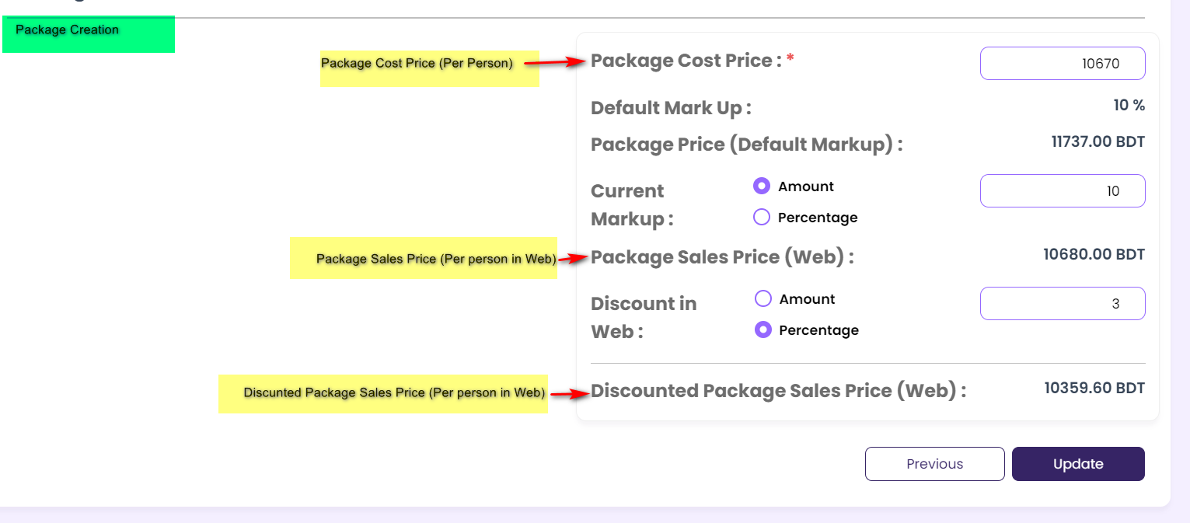

* 1. Alignment of the filed name and field as in the upper attachment
  2. Change the font size. Make it the same as tour package booking
  3. Show the read-only fields in ash color marked as shown in the upper attachment.
  4. Show the BDT beside the fields same as the tour package booking
  5. The discounted package sales price (web) will be the selling amount.
     1. Example: The calculated amount is 1311039.81. the system will show 1311040.00 both in the admin and public sites.

1. Change in the tour package booking “ Payment details” part

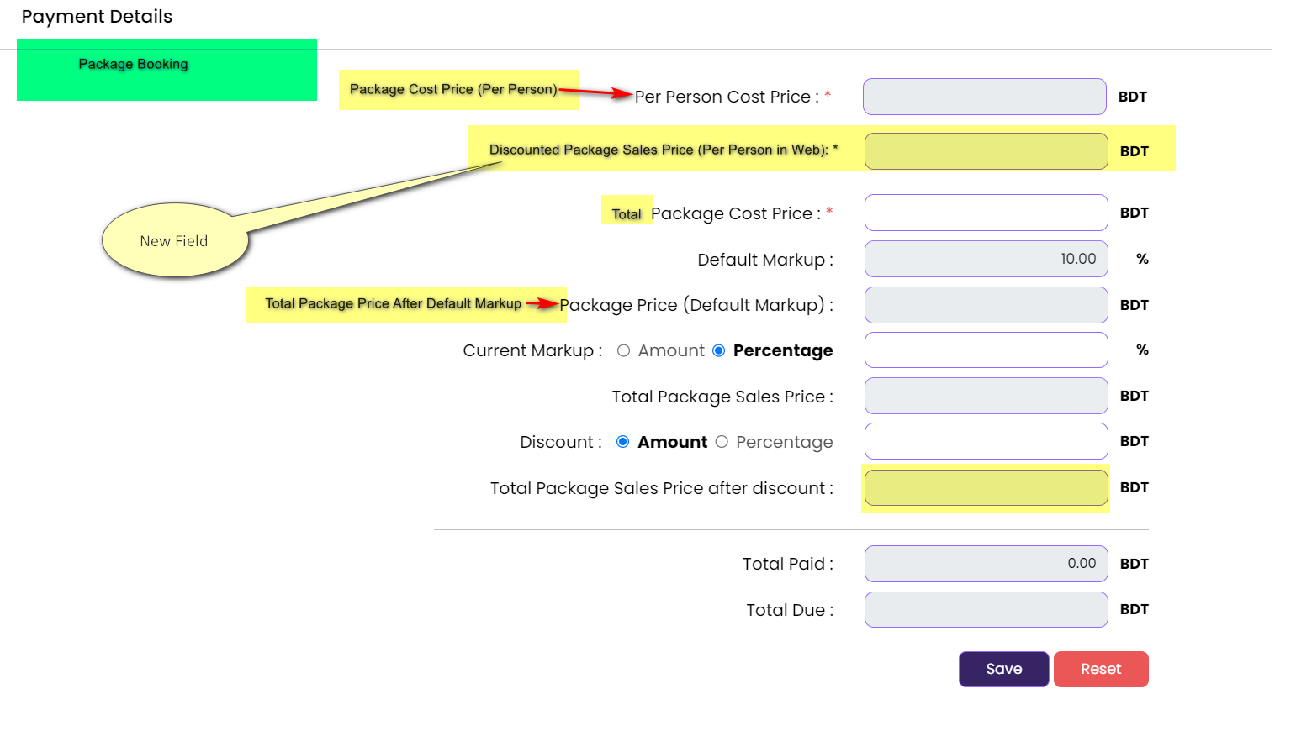

* 1. Alignment of the filed name and field as in the upper attachment
  2. Add a new field named “ Discounted Package Sales Price (Per Person in Web)
  3. The “total package sales price after the discount” will be the selling amount.
     1. Example: The calculated amount is 1311039.81. the system will show 1311040.00 both in the admin and public sites.
     2. The system will this amount in “Total service amount” in the payment claim UI.

1. Change in cancel booking
   1. On clicking the cancel booking icon the system will pop up a message box along with the remarks field which will be required.
   2. On clicking “Yes” the system will close the message box along with saving the cancel message and pop up the mail template of cancellation.
   3. On clicking “No” the system will close the message box and the system will not save the message and the system will not show mail templet
   4. The system will keep the package on the list if the package is not cancelled
   5. The system will not show the canceled package in the default list
2. Adding filtering criteria in the tour package booking list.
   1. The user will search the list data with the below filtering criteria

|  |  |  |  |  |
| --- | --- | --- | --- | --- |
| Sl No | Filed Name | Is Required | Data Type | Business Rules |
| 1 | Booking ID, Inquiry ID, Booking customer name, Booking customer mobile no, package name, location, | No | Dropdown | 1. Allows partial search 2. Users will be able to select single /multiple values. |
| 2 | Date Range | No | Selection of radio button | 1. Booking date 2. Inquiry date 3. Based on the selection the system will allow the user to enter the date range    1. From date    2. To date    3. Based on the selected date range the system will load the data    4. Date format: DD-MMM-YYYY    5. To date will not be lower than from date. |
| 3 | Booking Status | Yes | Dropdown | 1. Allows partial search 2. Users will be able to select single /multiple values. 3. Dropdown values are:    1. processing    2. confirmed    3. Cancelled |
| 4 | Payment status |  |  | 1. Allows partial search 2. Users will be able to select single /multiple values. 3. Dropdown values are:    1. Partial    2. Fully paid    3. Unpaid |